SHEEPY LAKE CASPIAN TERN ISLAND PROJECT
- PROJECT INFORMATION
P2 Identifier | 466191
Project Manager (PM) | Mike Turaski (NWP, 503-808-4704)
Technical Lead (TL) | Jeremy Britton (NWP, 503-808-4851)
Biologist/Coordination | Paul Schmidt (NWP, 503-808-4772)

- PURPOSE
The purpose of this project is to design and construct an island to replace the previously constructed floating island in Sheepy Lake, in order to ensure adequate nesting area in accordance with the 2008 FCRPS BiOp and the Caspian Tern EIS/ROD.

- BACKGROUND

In 2010 the Corps constructed a 0.8-acre floating island in Sheepy Lake, within the Lower Klamath National Wildlife Refuge (LKNWR), to provide nesting habitat for Caspian terns. The primary purpose was to develop alternative nesting habitat locations for Caspian terns, in conjunction with social facilitation measures, with the intention of reducing the number of terns nesting at East Sand Island in the Columbia River Estuary, thereby reducing their predation on juvenile salmonids through the estuary. Terns and other bird species use the created island, and it has contributed to meeting the overall tern habitat goal for the estuary.

Currently the floating island at Sheepy Lake is experiencing ongoing deterioration and is at risk of complete failure. Multiple failure points in both design and construction have increased the frequency and costs associated with operation and maintenance. Rather than repairing or constructing a new floating island, the Corps determined that the best course of action is to remove the floating island and replace it with a rock island, of a design very similar to those that have been built elsewhere (e.g., Crump Lake). The Adaptive Management Team requested, and the Corps may construct, a larger 1.0-acre island, to account for changed conditions at the Orems Unit Island (also within LKNWR).

- STATUS & ISSUES
- The project was initiated in March 2017, and has a very fast schedule. The Corps intends to award a construction contract in FY17 and complete construction by the end of March 2018.
- Improving the access route and constructing a temporary causeway will be substantial cost drivers.

- SCHEDULE & COST

YEAR | COST | MAJOR ACTIVITIES
FY17  Actual Obligation | $4,581,700 | Alternative evaluation, design, and construction contract award.
FY18  PBUD | $680,000 | Construction, S&A, EDC, and project close-out.

- PHOTOS & DRAWINGS

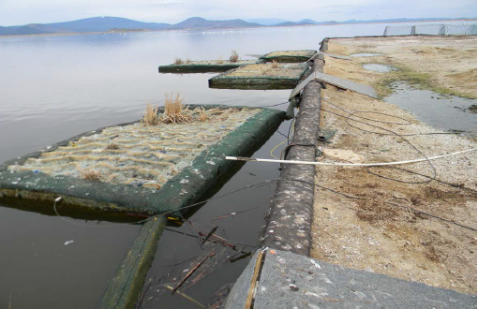
Floating island in September 2016. Units are becoming detached, and the island surface is buckling and starting to collect water.

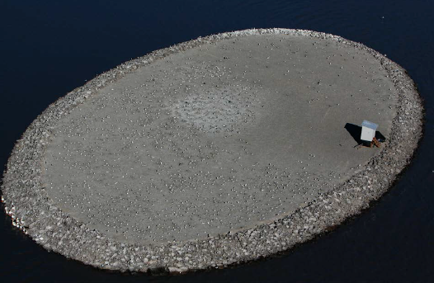
Rock island at Crump Lake. The new island at Sheepy Lake will have a similar design (shape, material, etc.).

